# Help file for ID Registration

The login screen (first screen of the app) has two text fields and two buttons

The you MUST fill both boxes and click register if new user, if you already have an account you must login with valid details

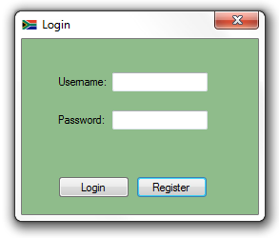

If you clicked register you will see this screen, after you click ok you will be taken to the registration form

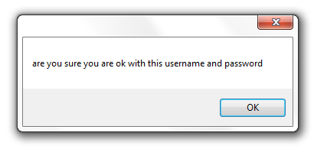

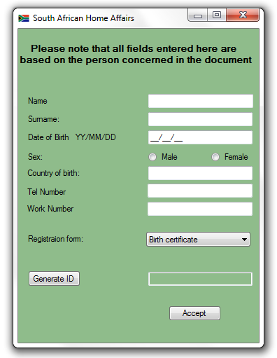Once you have completed loging in you will see this page South afican home affairs (below)

All fields on this form must be filled in on this page, it will serve for the basaic information on the person concerned.

After all the boxes are filled in you must select a registration form from the combo box and click accept

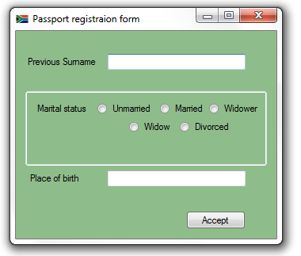This is the passport registration form (Below) you must again fill all the boxes and in the combobox may can only select one choice

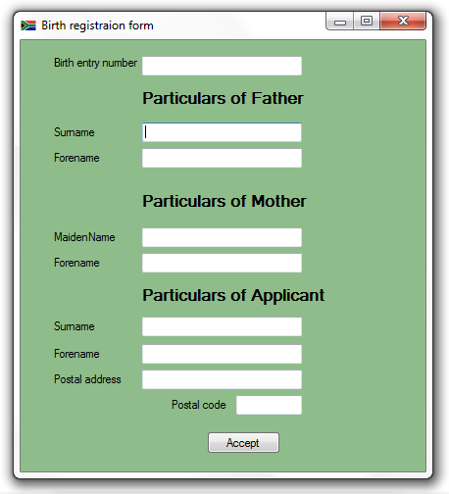

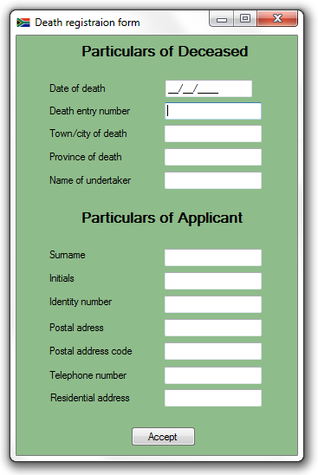Death certificate (right) is a registration form filled

out by a third person all text firlds must be filled in

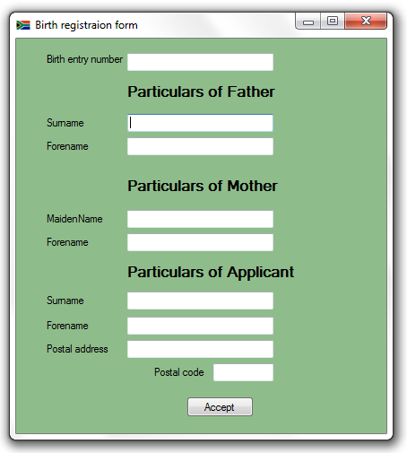date of death format is (dd/mm/yyyy)

Birth certificate, must be

filled with both mother

and fathers information

and that of the applicant